Sample Monthly Food Menu
Each month two to four food packages are offered for sale. The food menu is published at www.catholiccharitiesdc.org/share
Every month there is a value package and 1 to 3 special packages.
Value Package – Usually contains the following:
5 pounds of white potatoes.
3 pounds of onions
6 to 8 fruits and/or vegetables.
1 pound of chicken
Lentils
6 to 8 other food items.
Special Packages - Usually 1 to 3 special packages are offered each month. Examples of these packages are 5 pounds of pre-cooked chicken and 5 to 8 pound of steak at a cost ranging from $14 to $40. Samples of special order packages are:
- Beef Lovers’ – 10 -5.5 oz. portions of bacon wrapped sirloin.
- Veggie Lovers’ - 8 to 10 seasonal fresh product.
- Pasta Lovers’ - 8 to 10 pasta dishes.
- Pork ribs – Two large racks of ribs.
- Sliced Ham – This is usually offered in December.
- Turkey – This is usually offered in November.

The Frederick SHARE
Distribution site is sponsored by
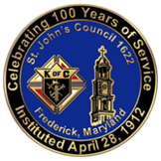
St. John’s Council #1622
Knights of Columbus
112 East Second Street
Frederick, Maryland
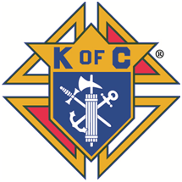
For more information, visit us at our website:
www.kofc1622.org/share.html

December 27, 2021
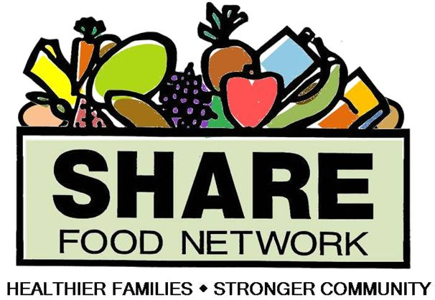

Frederick
SHARE
Food Co-Op
Location: Warehouse for Frederick Community Action Agency,
14 E. All Saints Street, Frederick, MD.

Sponsored by the
St. John’s Council #1622,
Knights of Columbus
Since 1996
What is the SHARE food Program?
The SHARE Food program is a national program which was started over 20 years ago. The food is provided once per month at over 200 sites in the Washington Metropolitan area. Under this program individuals can purchase food at reduced prices. The cost of the food is between 40% and 50% of what you would pay for the same food in a grocery store. The cost of a value package in any retail grocery store is $40-$45 and you only pay $23 under this program.
Who can order food?
Anyone can participate in the SHARE food program. You can purchase food from the program if you complete at least two hours of volunteer work per month. The volunteer work could range from taking a neighbor to a doctor’s appointment to doing volunteer work in any community program.
How can I pay for it?
You can pay for it with either cash, check, money order, debit card, credit card or Independence Card (food stamps). Checks and money orders should be made out to the Knights of Columbus. Send your payment to Brian Duncan, (240) 367-6490 cell/text,
email brian@tylerco.com
What does the food cost?
There are two types of food packages. The first package is called a value package and it cost $23. It includes basic and healthy groceries; always four to six pounds of frozen proteins and eight to 12 pounds of fresh fruits and vegetables, sometimes with seasonal grocery or dessert items.
The second package is called a special package. This package’s cost can range from $14 to $32, which depends on what food is offered.
Where and when can I pick-up the food?
Pick-up your food at the Warehouse for Frederick Community Action Agency, 14 E. All Saints Street, Frederick, MD., between 7:45 AM and 8:45 AM on the designated Saturday mornings.
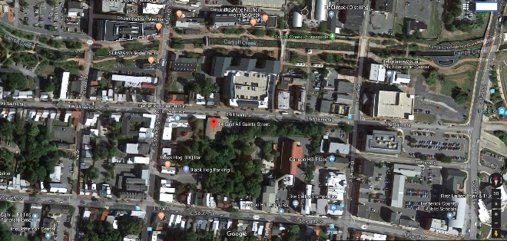
We can deliver food to shut-ins who have no means of picking up their food order, within a reasonable distance.
Monthly Food Calendar
Food Order Dates Food Pick-up dates
January 10, 2022 January 22, 2022
February 7, 2022 February 19, 2022
March 14, 2022 March 26, 2022
April 11, 2022 April 23, 2022
May 9, 2022 May 21, 2022
June 13, 2022 June 25, 2022
July 11, 2022 July 23, 2022
August 15, 2022 August 27, 2022
September 12, 2022 September 24, 2022
October 10, 2022 October 22, 2022
November 7, 2022 November 19, 2022
December 5, 2022 December 17, 2022
This schedule is subject to change. If the weather prevents us from picking up the food at the distribution site, the delivery date will be changed.

